**PATIENT DATA MANAGEMANT SYSTEM USING BLOCK CHAIN**

**Web and Mobile platform Update**

**Team:**

BHAVIRISETTI CHANDRASEKHAR – 16344254

BATTULA RASI HARSHINI – 16341280

BOLLINENI SANDEEP SAI – 16345740

MUKTA HARINI - 16343090

**Install the following applications in your system**

1. Ganache
2. MetaMask (Chrome Extension)
3. Node js or NVM
4. VS Code

**To Run the project in the VS Code, use the below commands**

1. npm install
2. npm run build
3. npm start (Then the server starts running)

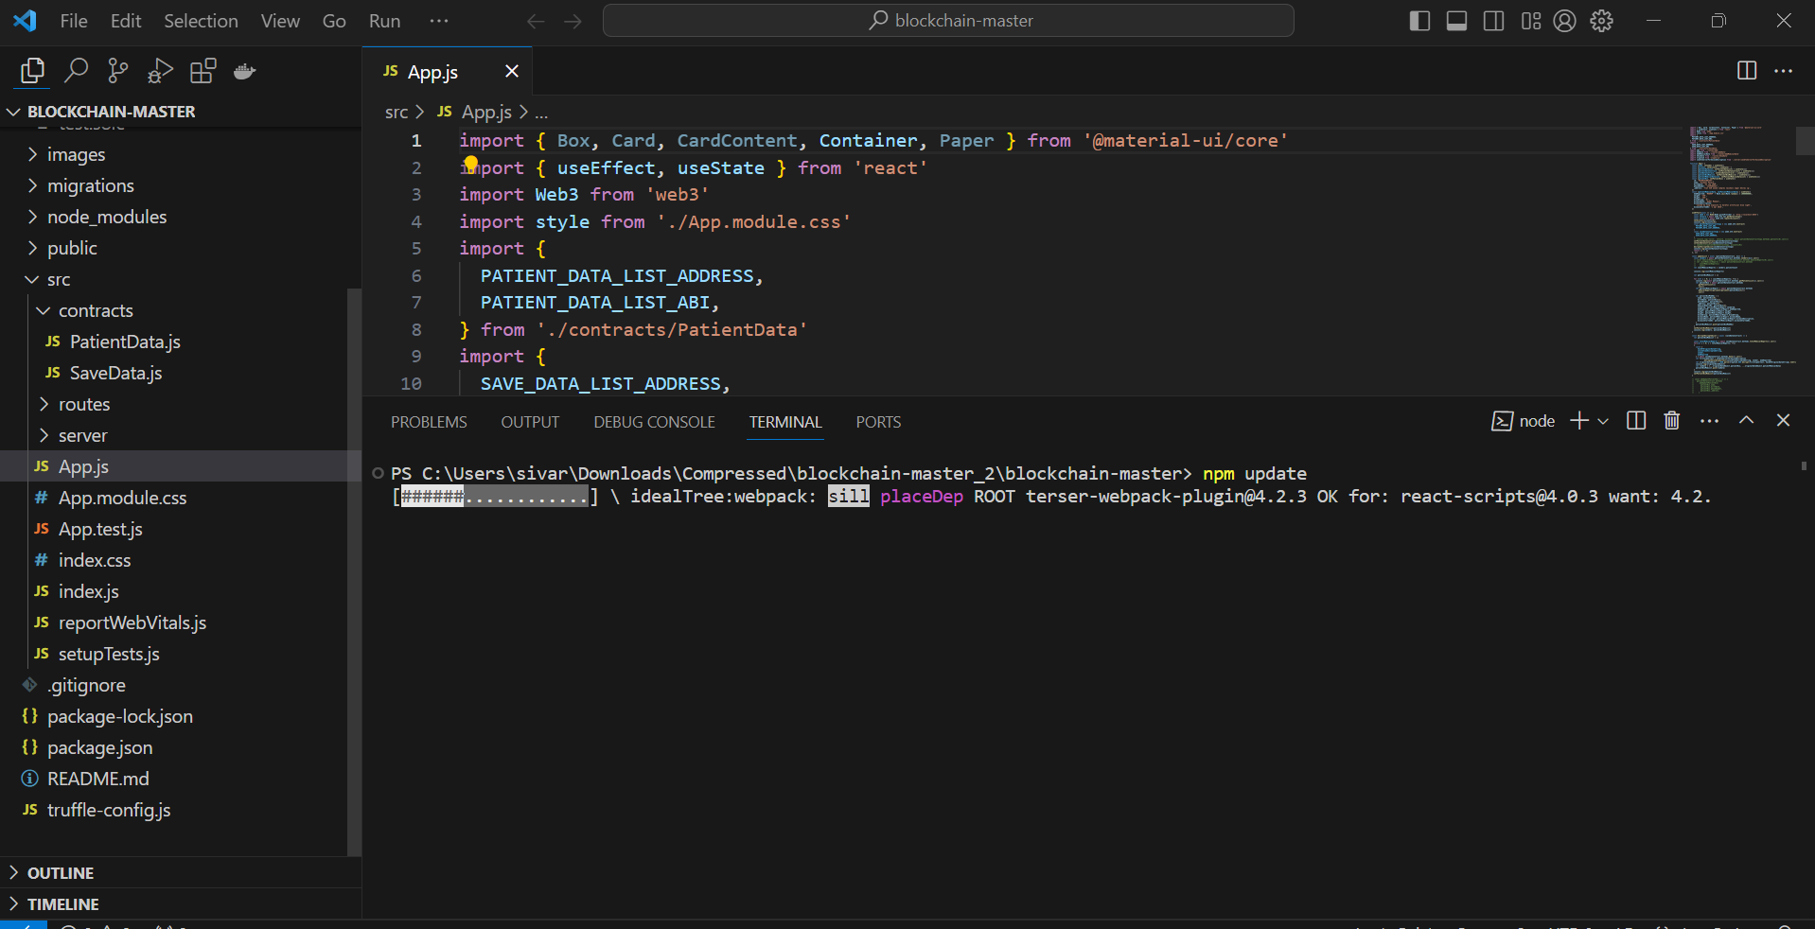

After you enter the npm start then starting the server development server and same you will observe in the Front-end. Please find the below screenshots

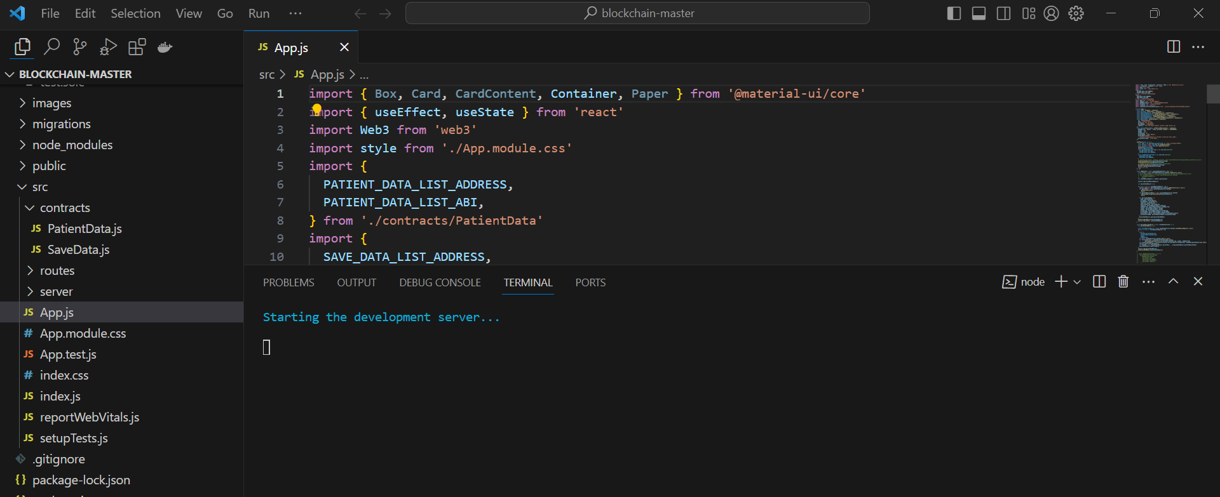

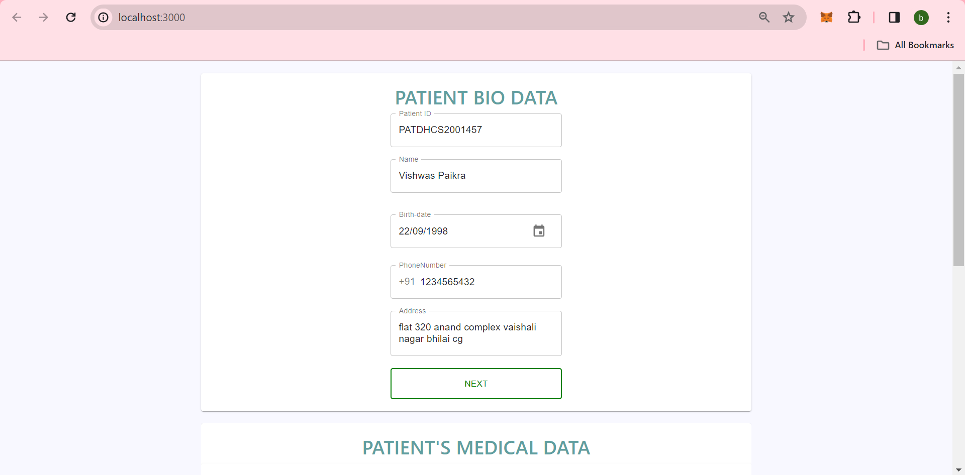

**Deploy the Contracts on the Blockchain Network**

Open Ganache and select quick start

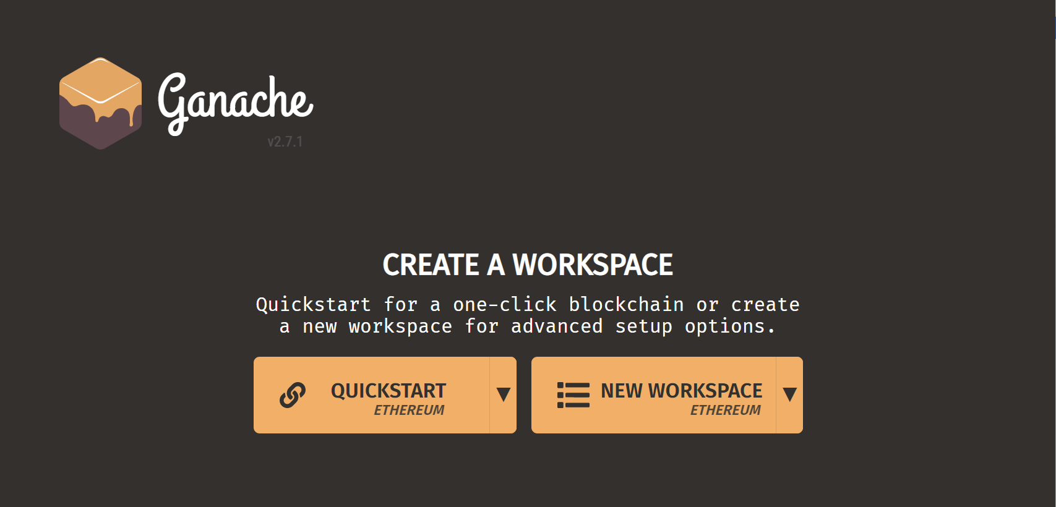

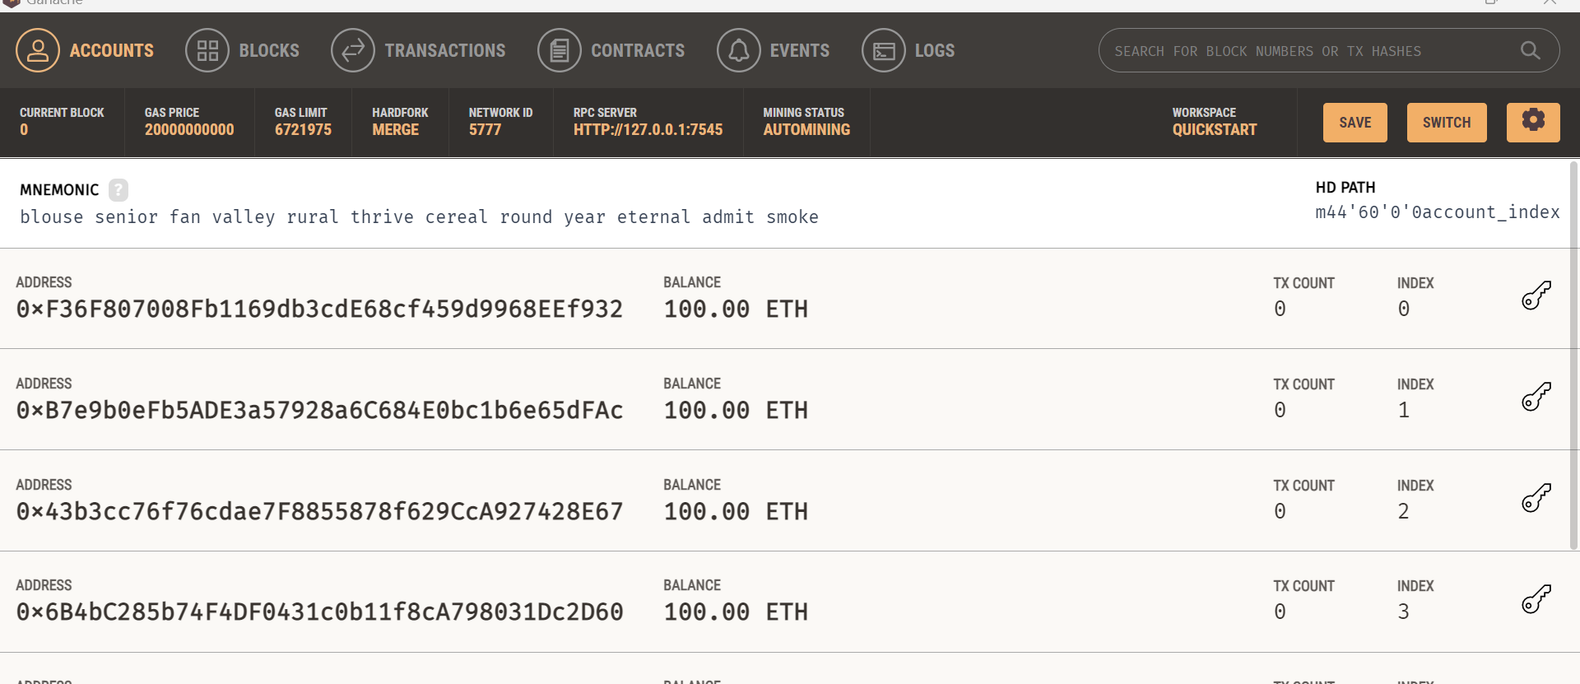

Make sure you have truffle installed

Use the link to install truffle <https://www.npmjs.com/package/truffle>

Use the command to install the Truffle - npm install -g truffle

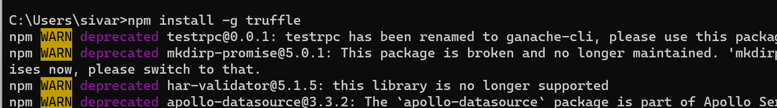

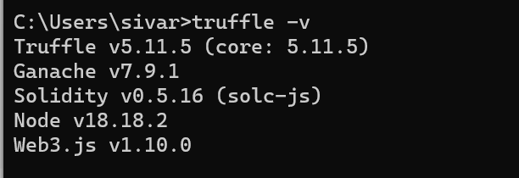

Once the truffle is installed – then deploy the smart contracts using the command truffle migrate

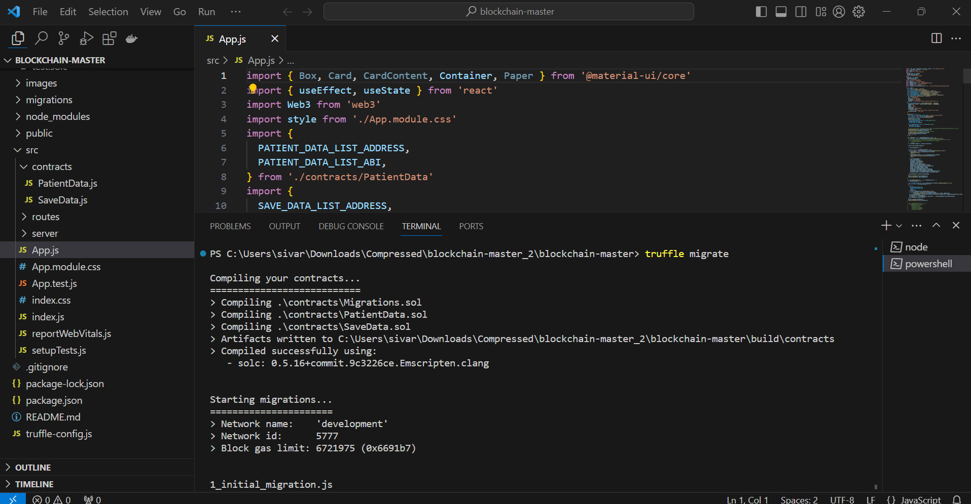

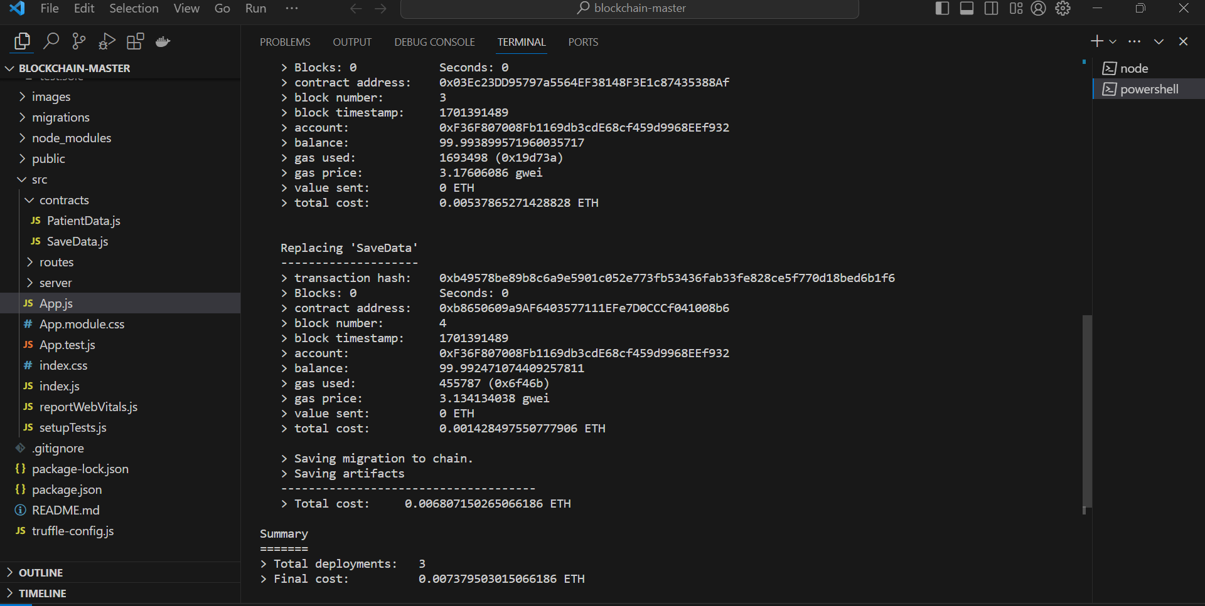

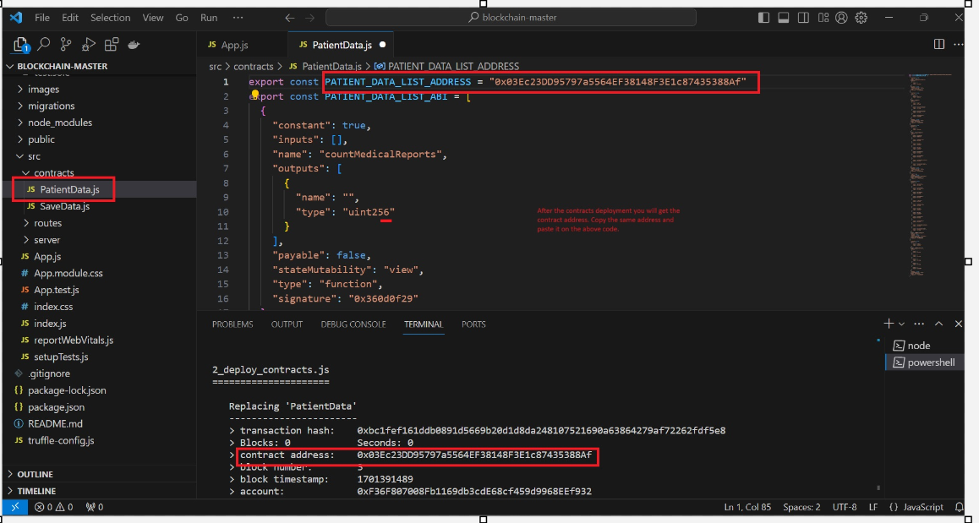

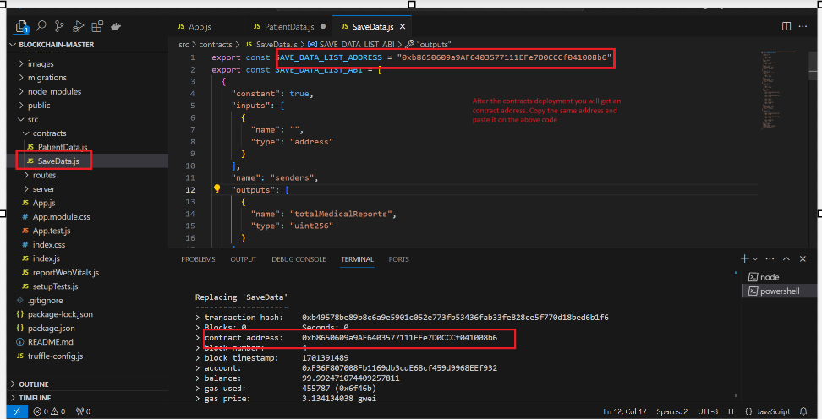

**Create an account in MetaMask:**

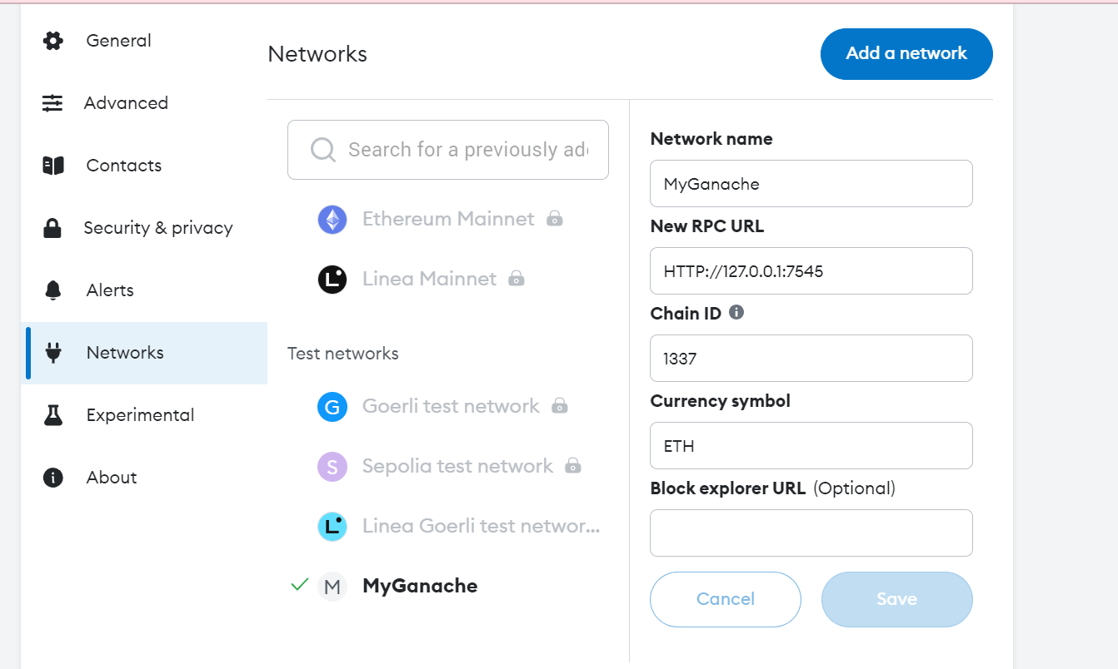

copy one of the private key present in Ganache app

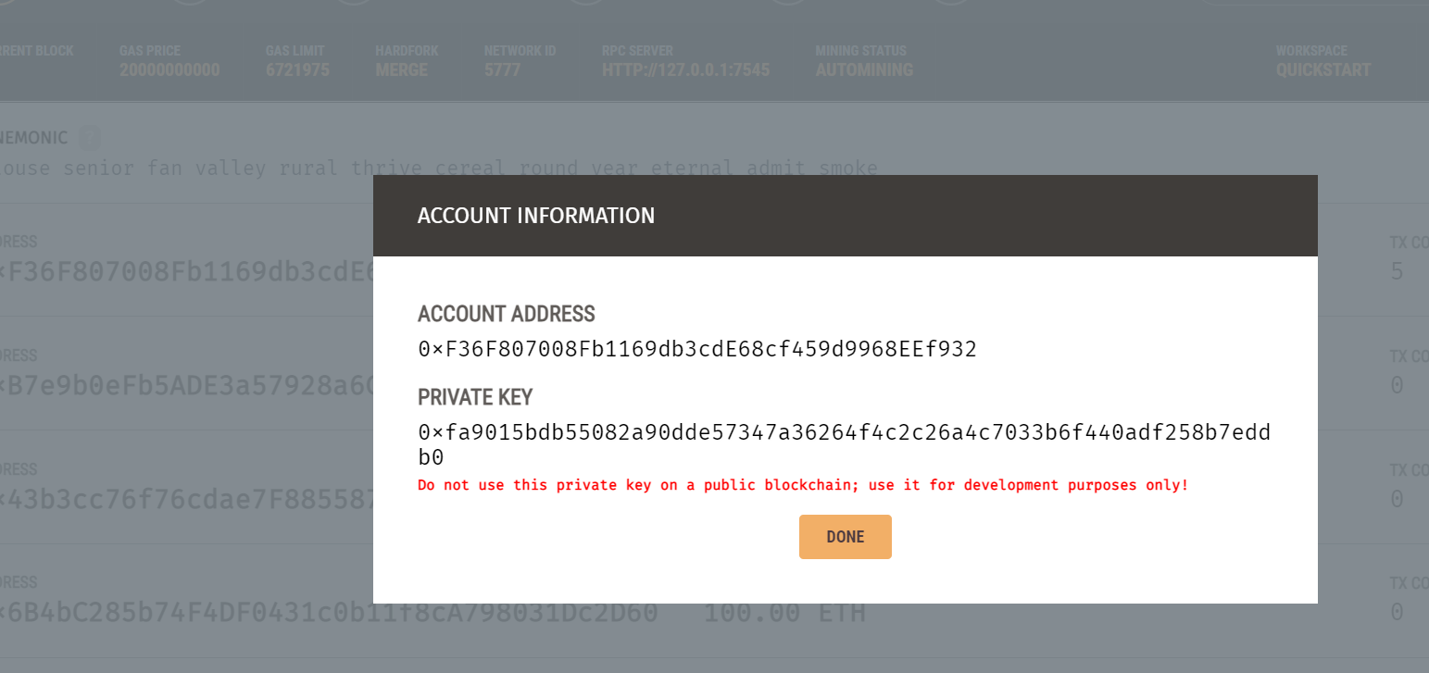

Import the private key in the metamask to create account and change not connected to connected

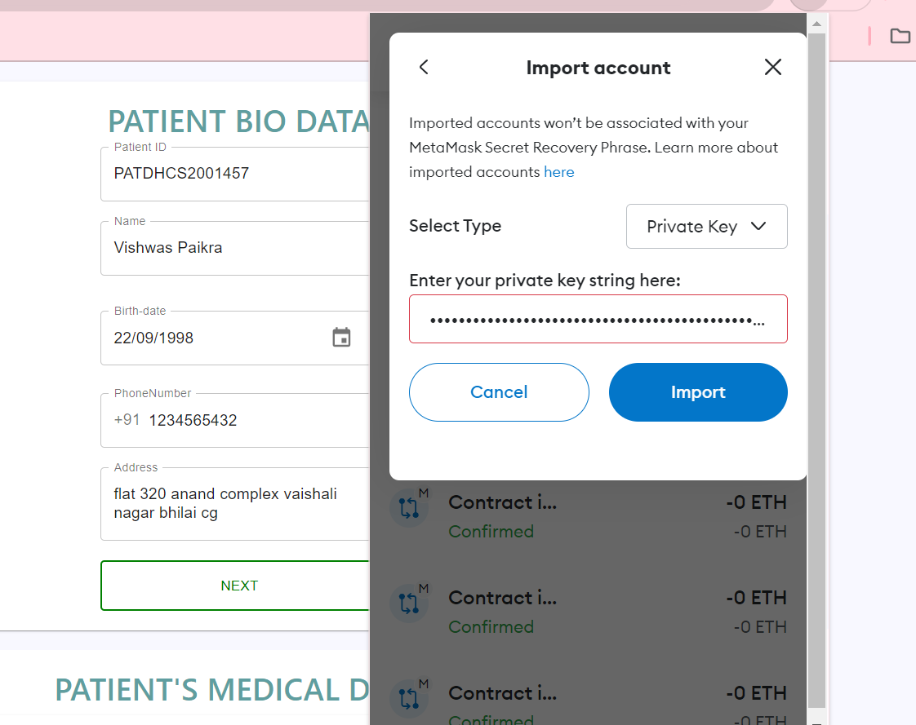

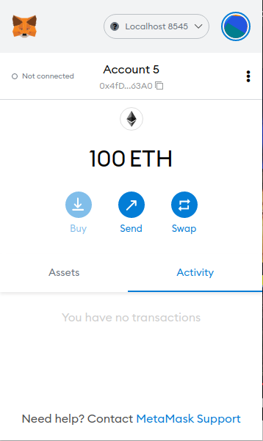

Once you enter the data from the front-end then MetaMask will interact with ganache (smart contract) and you have to confirm on that transaction.

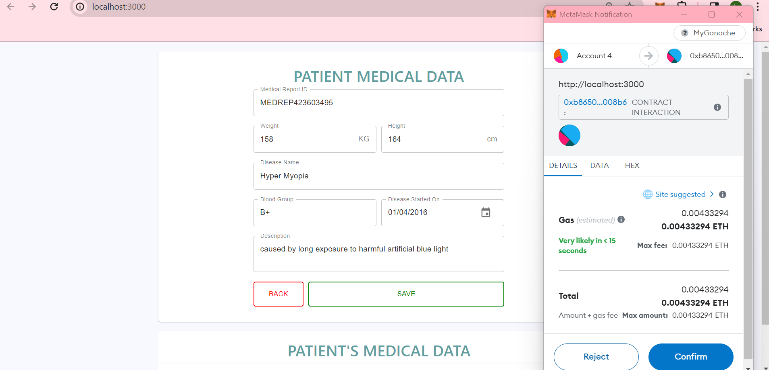

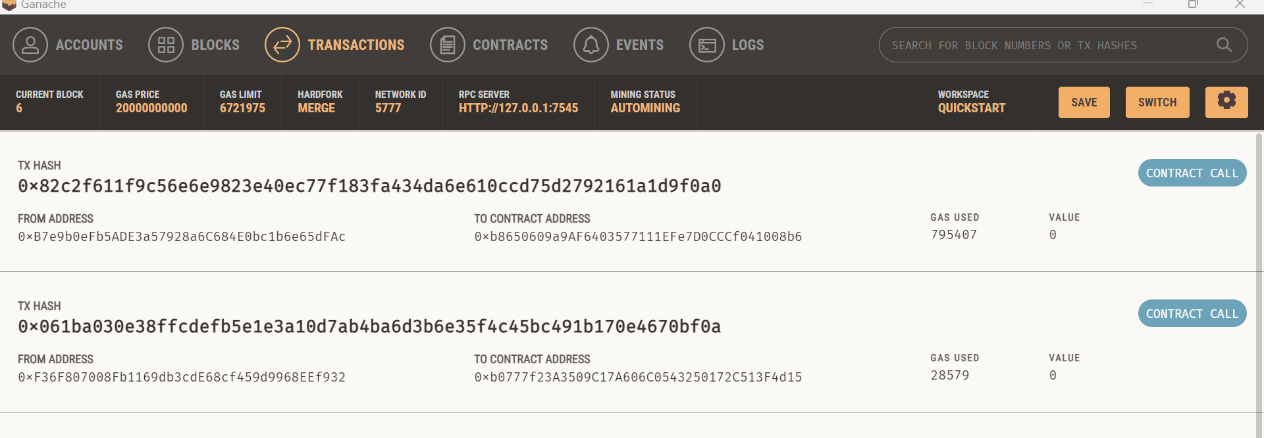

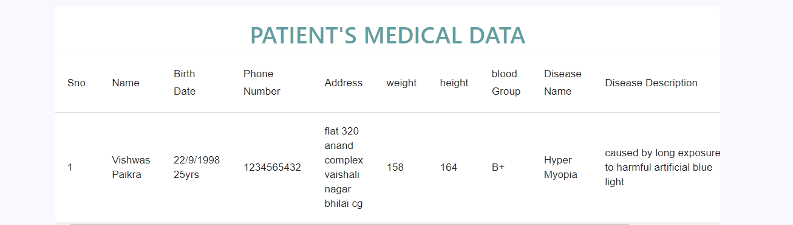

The Data storing is done via record of the patient details.

